**Addis Ababa Institute of Technology**

***Course: Computer Database Systems- ECEG-4191***

**PROJECT TITLE: BOOK AND ELECTRONICS GALLERY**

**Group 6- Members**

**Name ID**

**1. Natnael Dereje ATR/9015/11**

**2. Daniel Abera ATR/8231/10**

**3. Robenus Belete ATR/5356/10**

**4. Michael Abebe ATR/5354/09**

**5. Seare ALem ATR/6002/09**

**SUBMITTED TO: MR.TESFAMICHAEL**

**Due date: 03/05/2021 G.C**

UPDATED ER DIAGRAM (PHASE ONE)

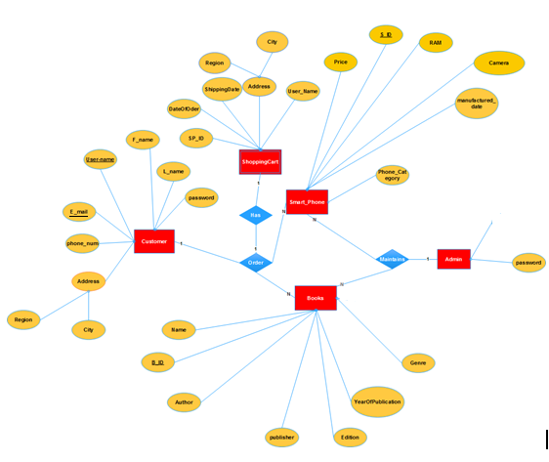

PHASE TWO

LIST OF FUNCTIONAL DEPENDENCIES

-Here are the functional dependencies on minimal basis:

**CUSTOMER**

FD1: Username {Password, F_Name, L_Name, Region, City, Phone_Num, E-mail}

**ADMIN**

FD2: AdUser {Password}

**BOOKS**

FD3: B_ID {B_Name, Author, Publisher, Ed., YearOfPublish, Price, Genre}

**SMARTPHONES**

FD4: S_ID {RAM, Price, Camera, Manu_Year, Phone_Num}

**SHIPPING CART**

FD5: Sh_ID {Shipping_Date, AdUser, Username, Region, City}

Other dependencies:

FD6: E-mail {Phone_Num, F_Name, Last_Name} ….. (Under Customer)

FD7: Username {Region, City} …… (Under Shipping Cart)

NORMALIZATION

The normalization of the given database has been given using the following normal forms:

1st Normal Form

**CUSTOMER**

|  |  |  |  |  |  |  |  |
| --- | --- | --- | --- | --- | --- | --- | --- |
| Username | Password | F_Name | L_Name | Region | City | Phone_Num | E-mail |

**ADMIN**

|  |  |
| --- | --- |
| AdUser | Password |

**BOOKS**

|  |  |  |  |  |  |  |
| --- | --- | --- | --- | --- | --- | --- |
| B_Name | B_ID | Author | Publisher | Ed. | PublishedYear | Price |

|  |  |
| --- | --- |
| B_ID | Genre |

**SMARTPHONES**

|  |  |  |  |  |  |
| --- | --- | --- | --- | --- | --- |
| S_ID | RAM | Price | Camera | Manufactured_Year | Phone_Category |

|  |  |
| --- | --- |
| S_ID | Phone_Category |

**SHIPPING CART**

|  |  |  |  |  |  |
| --- | --- | --- | --- | --- | --- |
| **Sh_ID** | Shipping_Date | AdUser | Username | Region | City |

2nd Normal Form

The 2NF remains the same as the 1st NF, because there is no any partial dependency here.

**CUSTOMER**

|  |  |  |  |  |  |  |  |
| --- | --- | --- | --- | --- | --- | --- | --- |
| Username | Password | F_Name | L_Name | Region | City | Phone_Num | Email |

**ADMIN**

|  |  |
| --- | --- |
| AdUser | Password |

**BOOKS**

|  |  |  |  |  |  |  |  |
| --- | --- | --- | --- | --- | --- | --- | --- |
| B_Name | B_ID | Author | Publisher | Ed. | PublishedYear | Price | Genre |

**SMARTPHONES**

|  |  |  |  |  |  |
| --- | --- | --- | --- | --- | --- |
| S_ID | RAM | Price | Camera | Manufactured_Year | Phone_Category |

**SHIPPING CART**

|  |  |  |  |  |  |
| --- | --- | --- | --- | --- | --- |
| **Sh_ID** | Shipping_Date | AdUser | Username | Region | City |

3rd Normal Form

This normalization is in 3rd normal form since there is no transitive dependency.

**CUSTOMER**

|  |  |  |  |  |  |  |  |
| --- | --- | --- | --- | --- | --- | --- | --- |
| Username | Password | F_Name | L_Name | Region | City | Phone_Num | Email |

|  |  |  |  |
| --- | --- | --- | --- |
| Email | Phone_Num | F_Name | L_Name |

**ADMIN**

|  |  |
| --- | --- |
| AdUser | Password |

**BOOKS**

|  |  |  |  |  |  |  |  |
| --- | --- | --- | --- | --- | --- | --- | --- |
| B_Name | B_ID | Author | Publisher | Ed. | PublishedYear | Price | Genre |

**SMARTPHONES**

|  |  |  |  |  |  |
| --- | --- | --- | --- | --- | --- |
| S_ID | RAM | Price | Camera | Manufactured_Year | Phone_Category |

**SHIPPING CART**

|  |  |  |  |
| --- | --- | --- | --- |
| Sh_ID | Shipping_Date | AdUser | Username |

|  |  |  |
| --- | --- | --- |
| Username | Region | City |

.

Boyce-Codd Normal Form (the same as 3NF)

The given 3rd normal form is also a Boyce-Codd Normal form, since there is a super key in each functional dependency that determines the rest attributes, as it can be seen in the list of dependencies.

Therefore, the highest normal form is the Boyce-Codd Normal form.

MAPPING

